WHITTLESEA

HISTORICAL

SOCIETY Inc.

ABN 46019570463

Well it is AGM time once again.

Most of this year has seen the Whittlesea Historical Society redesigning the new website.

We are trying to make it more user friendly as well as adding information that will prove useful to historians. This process does take time and we are also attempting to generate some income for paid research fees and copies of photographs from our collection. As with most big projects you have to start somewhere but as more information and photos get added it will become a valuable resource to many.

If any of our members have any ideas as to some feature they might like to see on the site please drop us an email via the web site page.

whittleseahistoricalsociety.org.au

MERNDA DEVELOPMENT

By Wendy Lowry

Back in September 1993 there was an article in the Whittlesea Post outlining the expected growth to the Mernda area. At the time the population of Mernda was about 700. It is interesting to see what they predicted 23 years ago.

Here are some excerpts from the article written by Karin Czernik.- Mernda Growth Revised

"Mernda's population is expected to grow to 40,000 in the next 20 years and not 60,000 as first proposed . The reduced estimate follows changes to the State Government's planning strategy which emphasises urban consolidation rather than new growth corridors. The Council advised that the Minister had not abandoned growth plans for the Plenty Valley but was calling for investigation into areas of untapped urban potential including the Epping area and the Merri corridor up to Wallan."

NEWSLETTER Number 24
October 2016

Editor Wendy Lowry

This Newsletter is kindly printed by the
office of Andrew Giles MP
(Federal Member for Scullin)

By December 1993 an updated article appeared in The Whittlesea Post written by Anna Ellis -
Subdivison gets go-ahead

"The first step in transforming Mernda from a small hamlet on Melbourne's outskirts to a new outer suburb has been given the go-ahead by Whittlesea Council. The Council will prepare an amendment to its planning scheme to enable subdivision of the Drapac and Humevale dairy sites. The approval follows confirmation from Melbourne Water that it can supply sewerage to 3000 households in Mernda and the neighbouring area of Doreen by connecting new properties to the existing Eltham sewer. It is said that sewerage and transport services were critical to the development of these growth areas. According to the Minister , provided there are no overwhelming environmental or other reasons, if an area can be serviced then it should be developed. "

Well you can be the judge whether or not they got it right as you drive up Plenty road from South Morang to Mernda.

WHITTLESEA HISTORICAL SOCIETY

Meetings 3rd Sunday each month
(Excluding January)
Time 2p.m.
Venue Whittlesea Community Activity Centre
Laurel Street, Whittlesea
Subscriptions Single $15
Family $20

RAILWAY HOTELS OF VICTORIA

As part of the Whittlesea Heritage Program for 2016, Scott Whitaker, author of the book "Railway Hotels of Australia - Volume 1 Victoria", presented an interesting talk about how the 'Railway hotels' came into being.

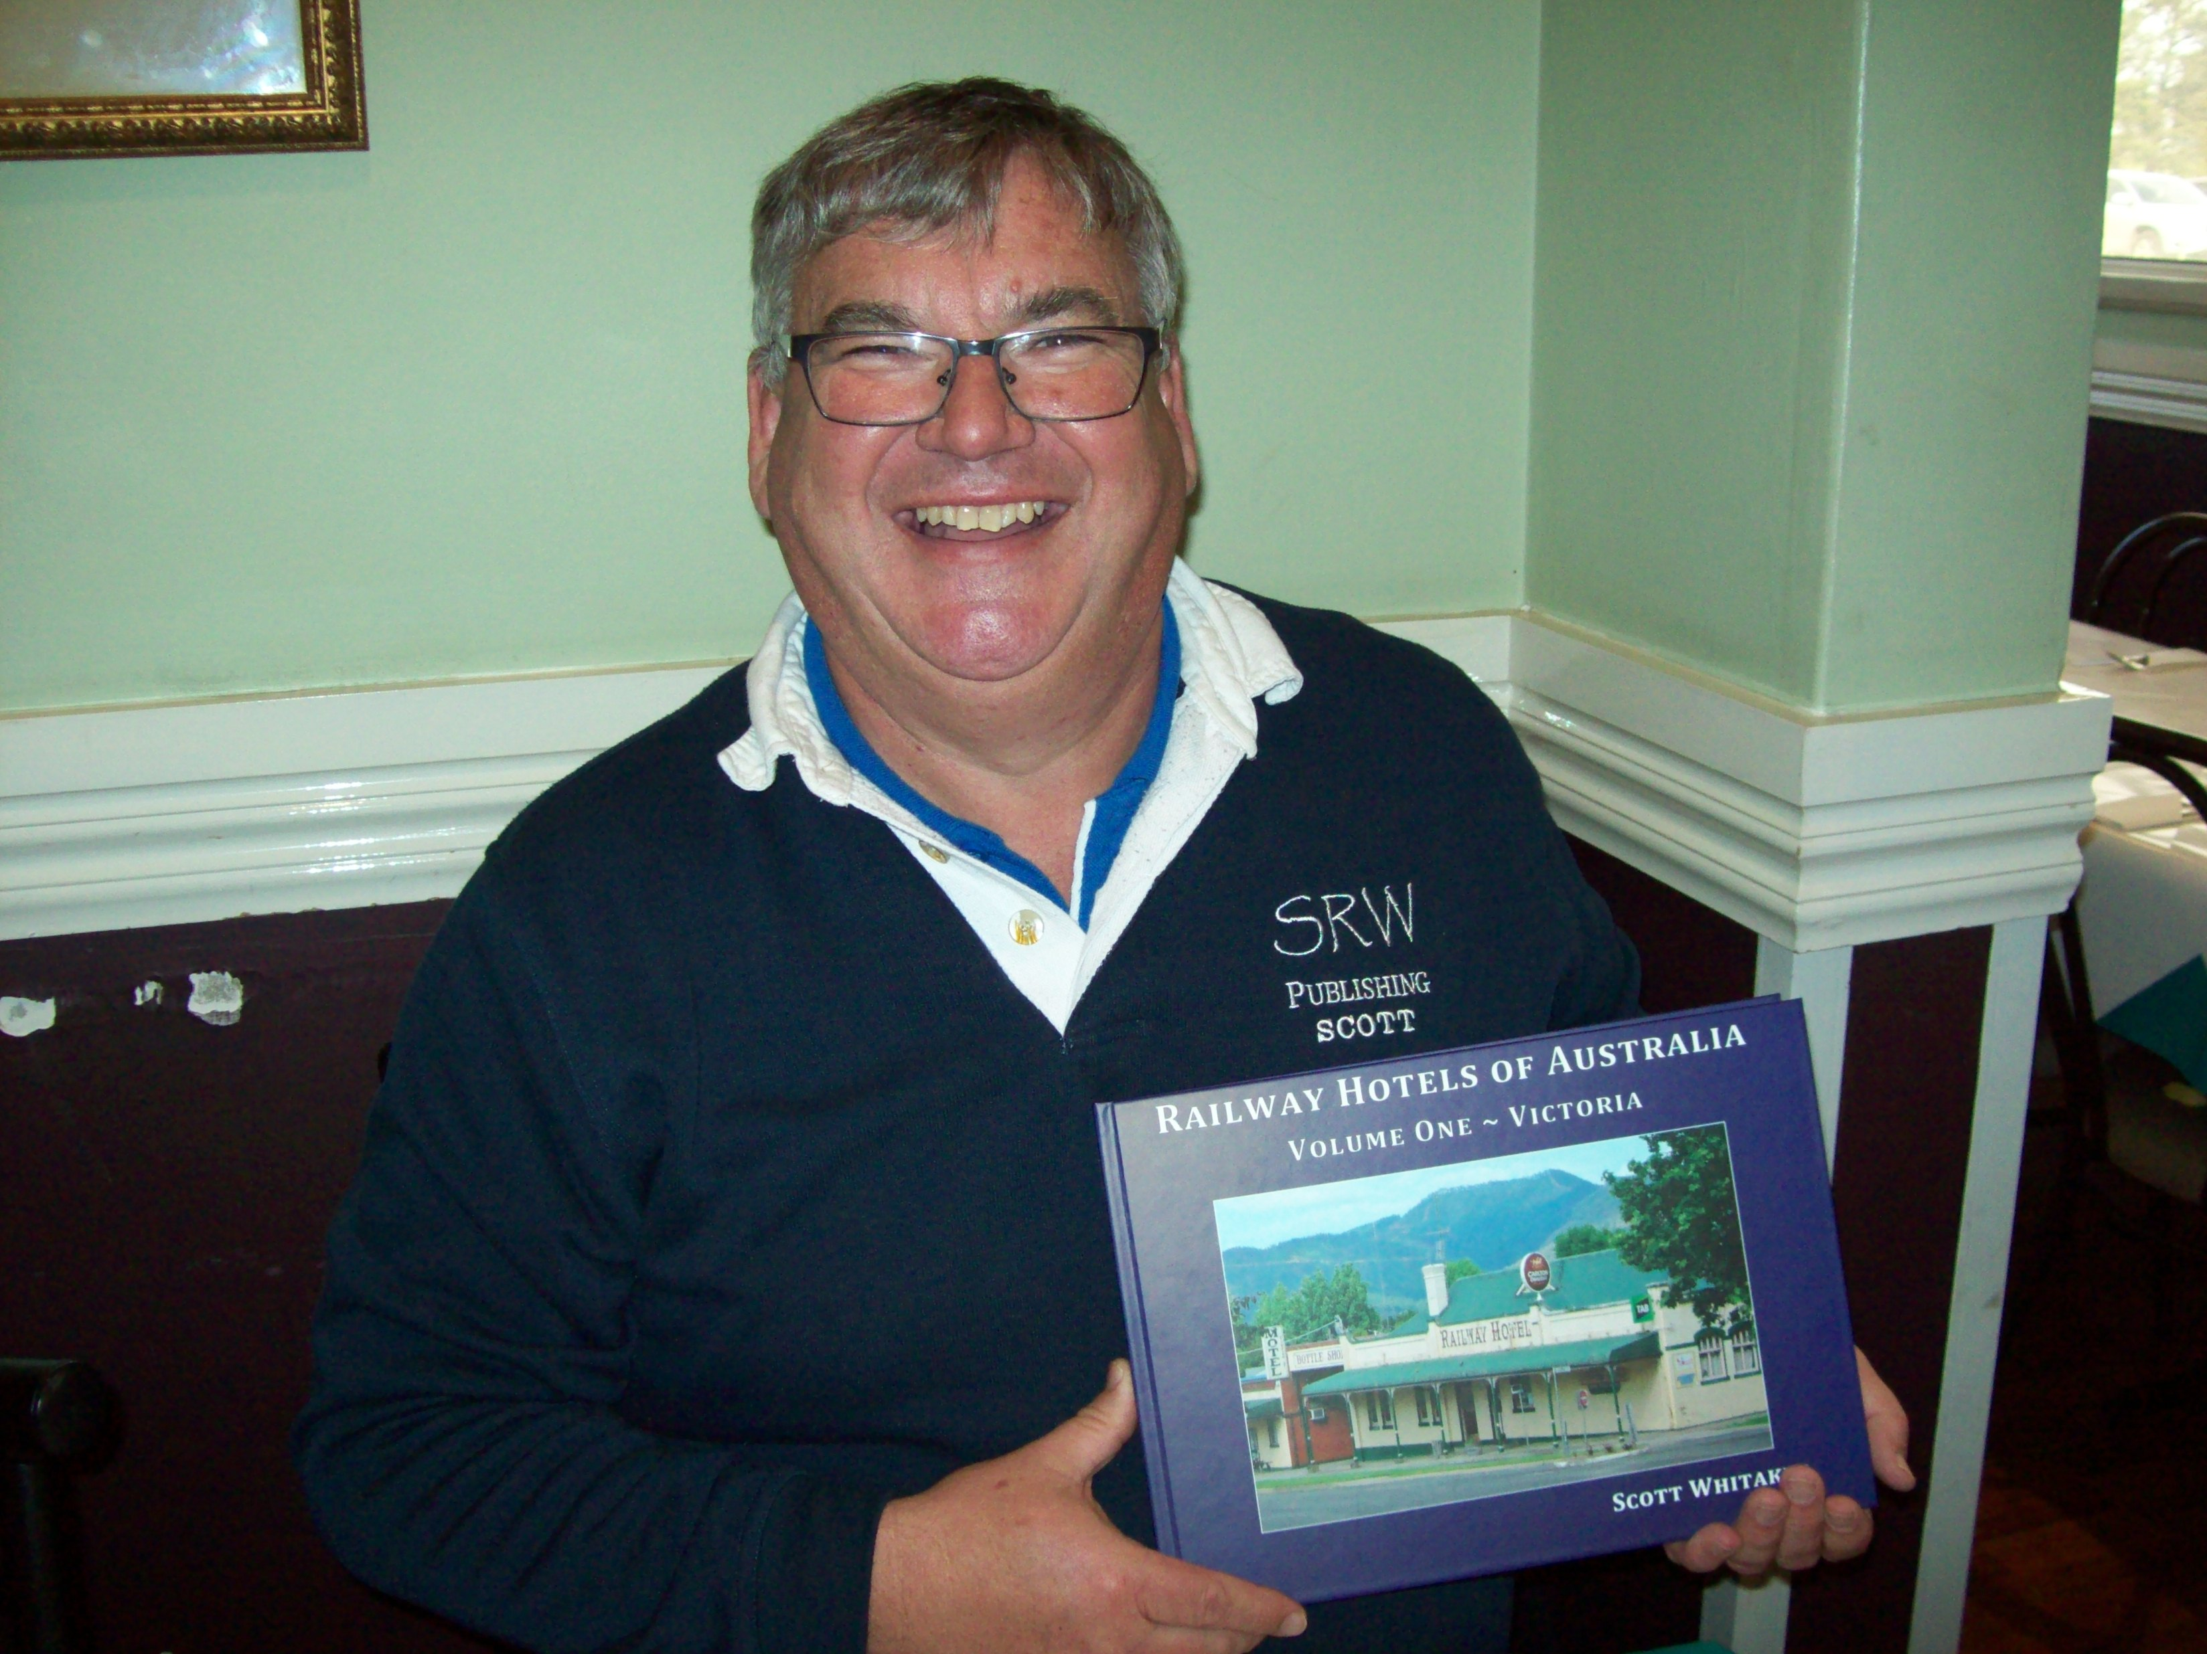

He explained the importance and history of the railways and its part in the development of townships. Originally hotels were established for the workers who were building them. Once they left, the area around the station developed. The Hotels then provided accommodation and food to travellers. The talk took place appropriately at the Donnybrook Hotel, formerly a Railway Hotel. It is located very close to the main rail line to Sydney.

The original town of Donnybrook was on the old Sydney Road (now the Hume Highway) however when the railway arrived in 1872 a small community developed around the new station 2km east of the original settlement and it became Donnybrook while the old settlement was renamed Kalkallo.

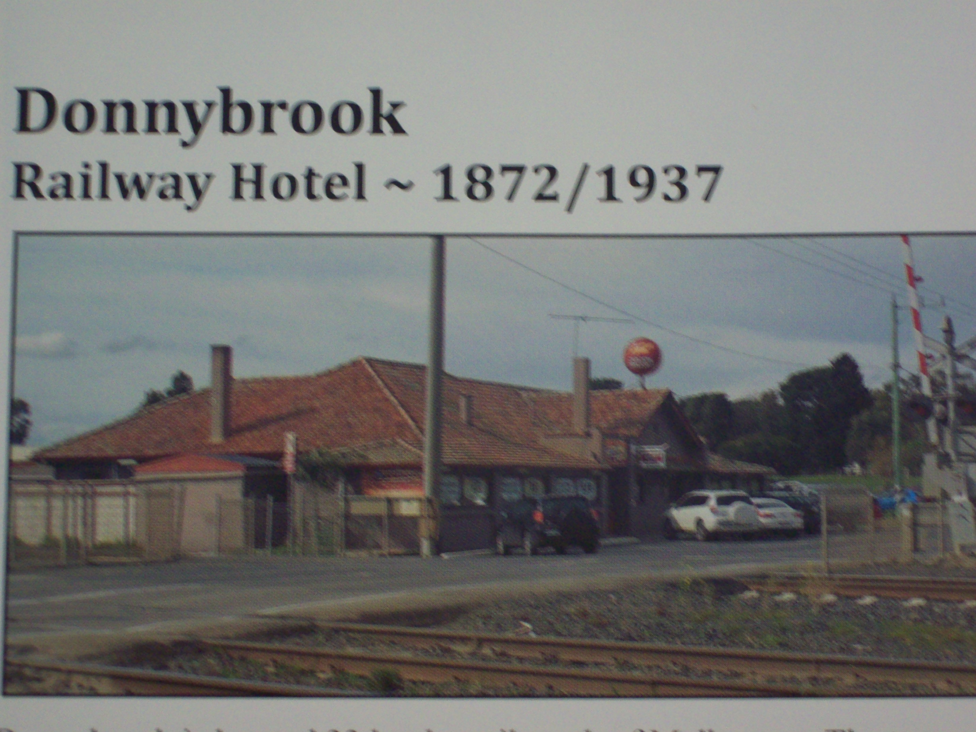

WHITTLESEA CULTURAL HERITAGE PROGRAM

The Program organised through the City of Whittlesea celebrates the rich history of the area.
Don't miss out on the wonderful opportunities to participate in the events that still remain for this year's program.

BEAR'S CASTLE TOURS
Date Sat. 22 October
Time 9.30 am and 1.30 pm
Where Whittlesea Courthouse
Visitor Information Centre
Cnr Church and Beech Streets Whittlesea, (Mel Ref 246 G8)
Cost $30 per person
Book Nesta Russell 9716 1866

CITY OF WHITTLESEA HISTORICAL TOUR
Date Sun. 23 October Time 10.30am - 12.30pm
1.30pm - 3.30pm
Where Mill Park Library
340 Plenty Road, Mill Park
(Mel Ref 10 C2)
Cost Free ( Bookings essential)
Book 9088 3465 Mon- Thu

HISTORY OF MONDAY MARKET
Date Fri. 28 October
Time 2pm. - 3pm.
Where Whittlesea Community Activity Centre, 57 Laurel St. Whittlesea
(Mel Ref 246 G9 )
Cost Free All welcome
Book www.yprl.vic.gov.au

YAN YEAN WATER SUPPLY SYSTEM
Date Sun. 27 November
Time 9.30am - 4.30pm.
Where Caretaker's Cottage
Preston Reservoir
1 High St. Reservoir (Mel 18 G7)
Cost $40 per person (Bookings essential)
Book Online at www.whittlesea.vic.gov.au
Follow links to events page.

WHERE DID THAT COME FROM?

"FERRIS WHEEL"

The fairground attraction made its debut at the 1893 World's Columbian Exposition in Chicago as America's answer to the Eiffel Tower which had been such a sensation at the Paris exposition four years earlier. The original ferris wheel was designed and constructed by Illinois engineer George Washington Gale Ferris (1859-96).
He was more used to constructing bridges and railroads. The wheel measured 250 feet in diameter and had thirty-six carriages, each capable of carrying up to 60 people. In all the big wheel could hold as many as two thousand at one time.

"NISSEN HUT"

The semi-cylindrical shelter made of corrugated iron on a cement floor was used chiefly for temporary accommodation during World War 2. The building was invented by a Canadian, Lieutenant-Colonel Peter Nissen (1871-1930).
He had served in the British Army during the First World War. The first Nissen hut was built on the Western Front and used as a troop shelter and equipment depot.

VALE

ILMA DUNCAN 1922 -2016

Long time member of the Whittlesea Historical Society.
Founding member of the Plenty Valley Arts group at Hawkstowe Park.

**************

LIFE BEHIND THE
GRAVESTONE
By John Waghorn

AHERN Thomas and Bridget

Thomas Ahern was born in Tipperary, Ireland in 1827 and arrived in Melbourne in March 1841. After farming for two tears and paying a two years' visit to New Zealand he returned to Victoria.
After shearing on some of the principal stations up country, the gold fever in 1851 saw him starting a carting business to Bendigo and other diggings.
Having his own teams on the roads and obtaining as high as £160 per ton for carriage.

In 1857 he settled down on the Mount Pleasant Farm in Epping. It comprised of 250 acres purchased from the Government. He was married on the 29th January 1851 to Bridget Hennan. and on his death on the 5th March he left a family of eight children. Bridget Ahern died on the 22nd August 1908. Their farm was located in Cemetery Lane ( Now O'Hern's Road Epping).

This road however is actually named after Terence O'Hern whose family coincidently arrived from Tipperary in 1841. His farm was called Roxburgh and was next to Thomas' property.

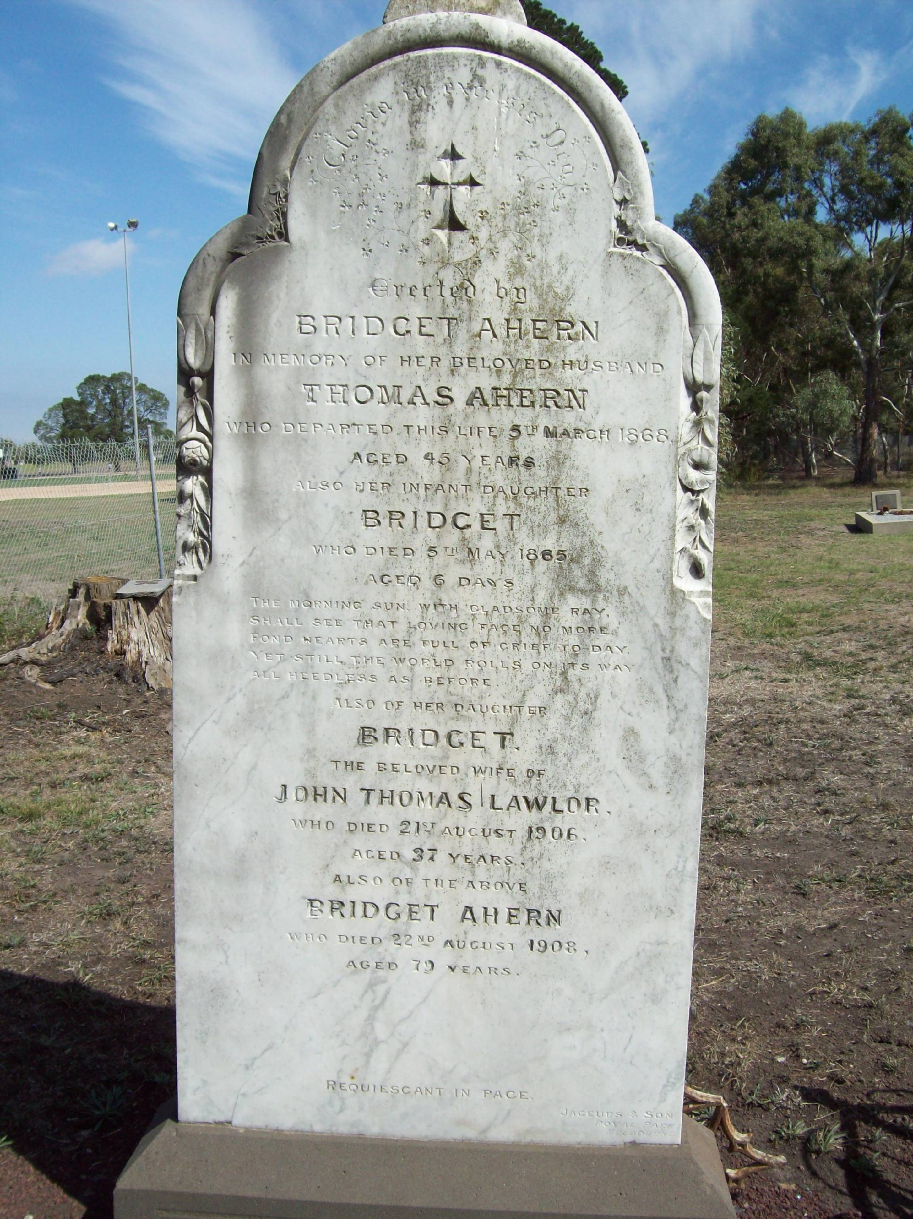

Gravestone at Epping Cemetery

ODD SPOT
By Gwen Hawke

The Argus, Wednesday 25 May 1859

"On Wednesday last the Whittlesea Branch of the Victorian Agricultural Society held its annual ploughing match on the property of Mr John Maxwell.

The farmers f the Whittlesea and Upper Plenty on this occasion mustered 19 teams of more than average excellence. Of the ploughs used, Sellars' and Grants', of Simpson's Road made superior work which contrasted very favourably with the work done by Barrowman's ploughs.

The quantity of land allotted to each team was half an acre in three gathered rigs. The ploughs were started punctually at 9 am. and finished the work shortly after 2 pm. The judges did not come on the ground until after the ploughs had all cleared away- an arrangement which appeared to give great satisfaction to the competitors.

The judges of the ploughing were - Mr Robert Robson of Whittlesea ; Mr J.D.Brown of Banyule ;
Mr Timothy Creighton of Lancefield.

CLASS A - Horse Teams ( Open to All )
1.Robert Kelly, Mr.David Johnston , Whittlesea
2.Matthew Copeland, Mr David Johnston Jnr, Whittlesea
3.Thomas Munday, Mr Robert Munday, Lower Plenty
4.Lewis Murray, Mr Robert Slessar, Lancefield
Prizes were awarded as follows for CLASS A:
First prize No. 3, Second Prize No.4
Third prize No.2.

The Hon. J.P.Fawkner gave £5 to be distributed amongst the unsuccessful competitors."

******************

LOCAL HISTORY MONTH

The Yarra Plenty Regional Library group have a variety of speakers this month talking about local history and related topics to family Genealogy. Do yourself a favour and go along . The talks will be in the libraries within the Plenty Valley Region.

Local History on Display
Mill Park Library Sat. 1 Oct - 31 Oct.
Eltham Library " "

Researching Your House
Rosanna Library Tue 18 Oct 11am - Noon

Lalor Conversations
Lalor Library Thu 13 Oct 1pm - 3pm

Westgarthtown and WW1
Thomastown Library Wed 19 Oct 11am - Noon

Whittlesea's Honour Boards
Whittlesea Library Mon 24 Oct 2pm - 3pm

Antiques Roadshow
Watsonia Library Sun 23 Oct 2pm -3.30pm

Tales of Yan Yean Cemetery
Whittlesea Library Wed 26 Oct 2pm - 3pm

Preserving Your Collection
Diamond Valley Library Wed 26 Oct 2pm - 3pm

ANNIVERSARY EVENTS

TOWN CRIER'S 30TH ANNIVERSARY &

WHITTLESEA COURTHOUSE VISITOR INFORMATION CENTRE'S 20TH

Sunday 16th October 2016 10am - 4pm

Displays will feature in the Whittlesea Masonic Hall and in the Courthouse.

For further information contact Sue Ewert
on 9716 2267

A PLACE TO VISIT

GEORGE SHERWIN BANDSTAND

In the grounds of Whittlesea Recreation Park there stands the incredible George Sherwin Memorial Bandstand.
This Structure was erected and officially opened on Sunday 11th November , 2001 as a memorial to the first Pioneer of the Whittlesea District, George Sherwin. The plaque on the bandstand was unveiled by Graeme R. Sherwin who was a direct descendant of George.

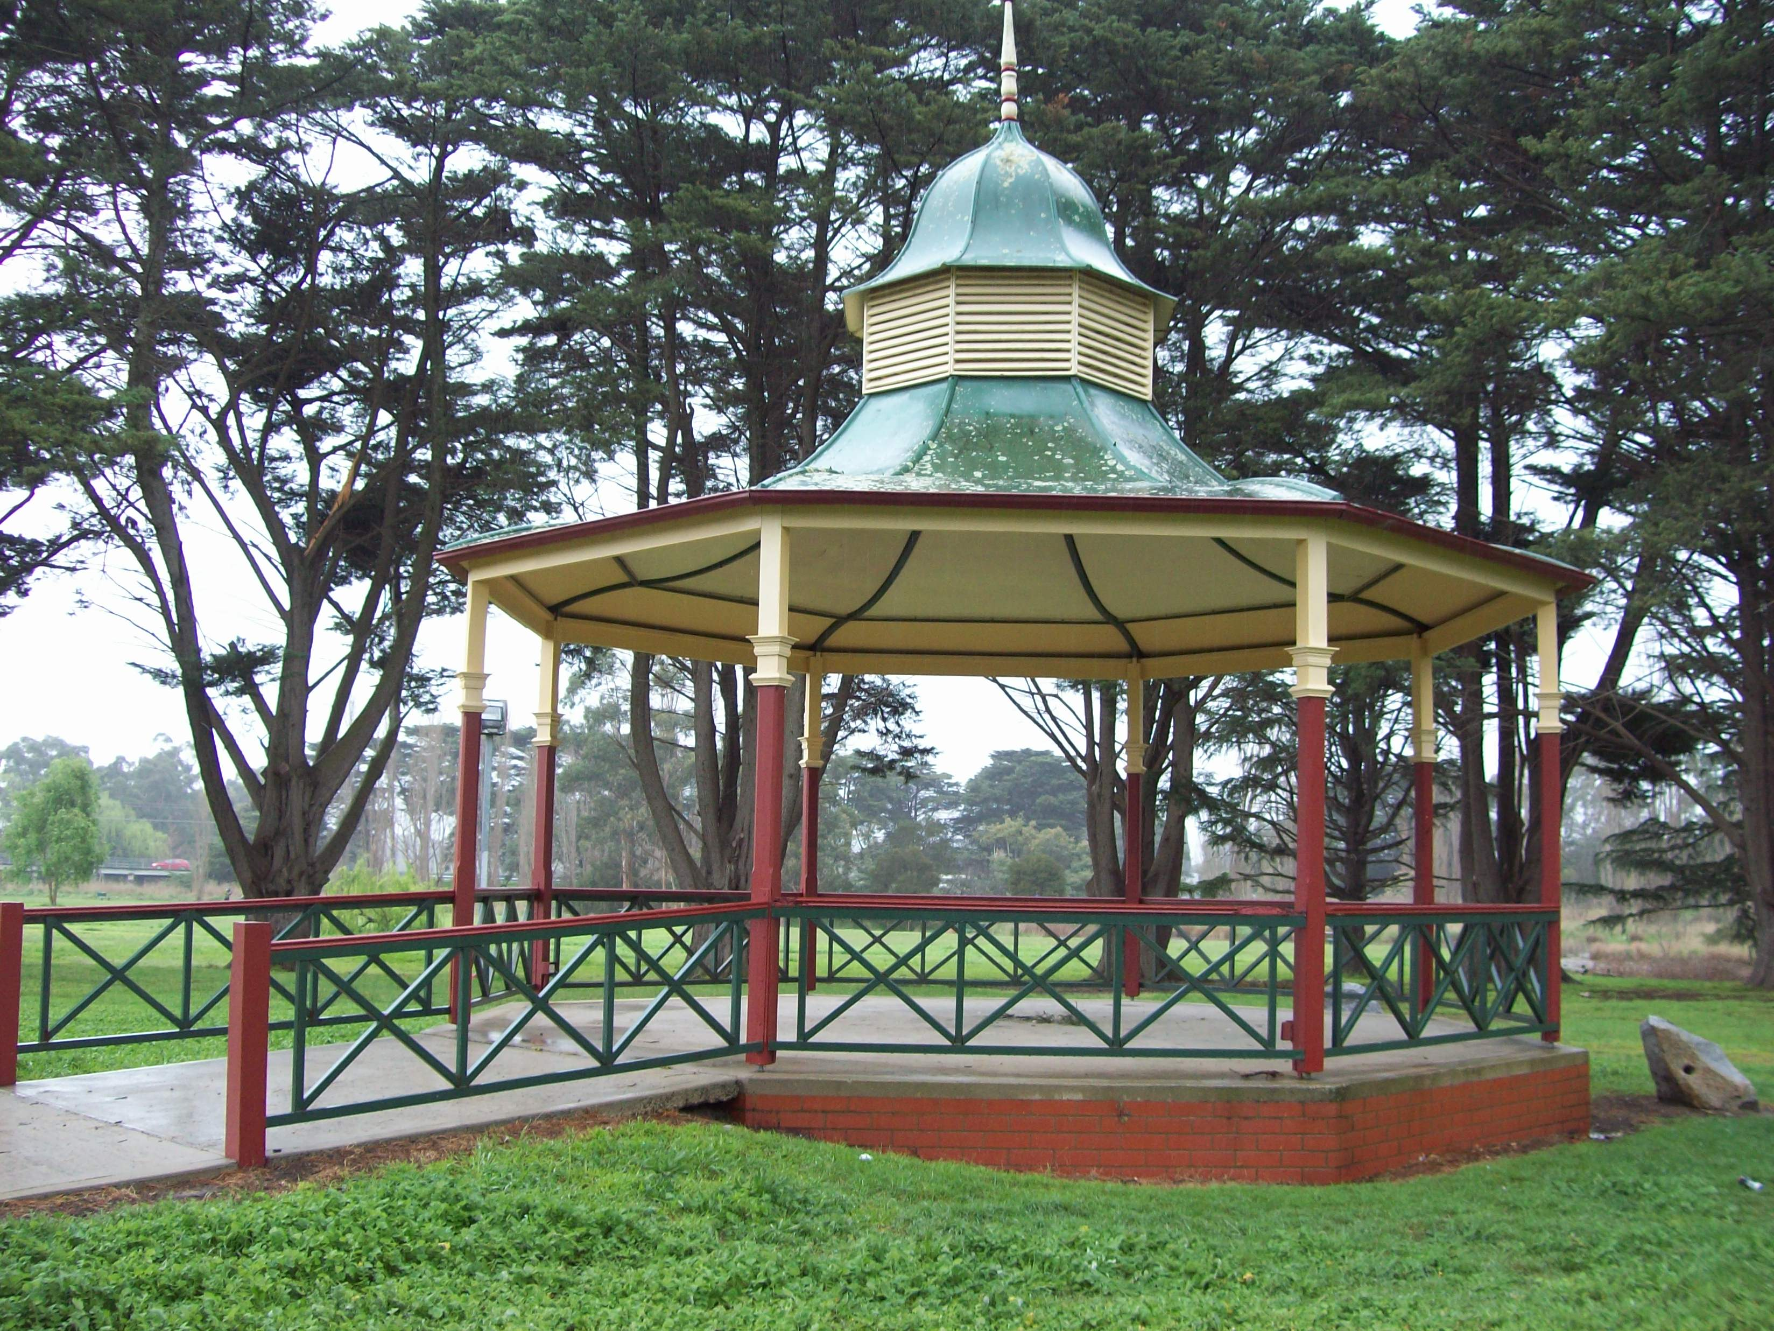

George was born in Parramatta NSW in 1816 and sailed to Port Phillip district in the late 1830's with his brothers John and Thomas. George wished to take up land and in 1837, followed the Yarra and the Plenty Rivers to what is now Whittlesea. When Robert Hoddle surveyed the area in 1838 he found George's station already established with a hut and stockyards on the east side of the Plenty River. This area is now the Recreation Reserve and includes the bandstand site. By late 1838 George had built his slab cottage on what is now Eastern Hill.

He married in 1841 Mary Thorn and they had 14 children. As the family grew in size George bought the property of 1,270 acres , which they called "Strathnoon" and built a more substantial home. He and the family raised sheep and established a vineyard. The house built in 1855 is still standing and is known as "Lyndoch Park".

WHAT'S IN A NAME?
By Gwen Hawke

"MASONS ROAD"

They say that in 1855 the families of Samuel JEFFERIES and John MASON bought their properties along what was originally a track between Mernda and Wollert.

The road construction began shortly after and the story goes that the surveyors who were sent to map out the land for the road began at each end . One from the High Street end and the other from the Plenty Road end. Unfortunately when they came together they were not in line and so the road that was constructed has a sharp bend in the middle. This bend is still there today.

Once the road was completed a name was sort. It was agreed that a toss of a coin ( probably a sovereign) was a fair answer. John MASON won the toss and came up trumps.

Originally is was referred to as MASONS LANE however this was changed more recently into MASONS ROAD.

Had the toss been won by Samuel then we would have had JEFFERIES ROAD.

WHITTLESEA HISTORICAL SOCIETY
ANNUAL GENERAL MEETING
Sunday 9th October 2016

Our Guest Speaker this year is Mr Paul Balassone who works for Melbourne Water. His talk is-

‘Eastern Hill Water Tank – Melbourne’s Early Water Supply System’.

